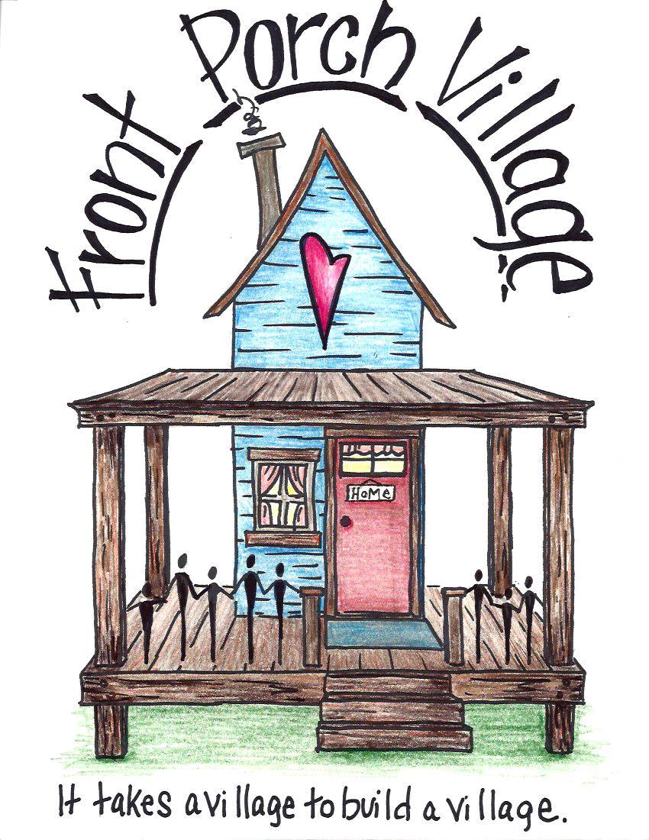

**Front Porch Village Collective Application Referral Form**

Date:________

Full Name of Applicant:________________________________________________

Date of Birth:______________ Social Security Number:_____________________

Present Address:_____________________________________________________

Employed: Yes or No If so, Where:_______________________________

Hours per week worked:_________ Income per month:_____________________

Referred by:______________________ Phone number:______________________

* A onetime $40 Application and Background Check Fee

Agree: YES NO

**Additional household member(s)(Children/Dependent)**

Full Name:__________________________________________________________

Date of Birth:______________ Social Security Number:_____________________

**Additional household member(s)(Children/Dependent)**

Full Name:__________________________________________________________

Date of Birth:______________ Social Security Number:_____________________

**Additional household member(s)(Children/Dependent)**

Full Name:__________________________________________________________

Date of Birth:______________ Social Security Number:_____________________

**Vehicle/Driver ID**

Driver’s License Number:________________________ State Issued:___________

Car Model :_____________ Color:____________ Year:__________

License Plate Number :______________________

**Additional Car:**

Driver’s License Number :________________________ State Issued:___________

Car Model :_____________ Color:____________ Year:__________

License Plate Number :______________________

**Emergency Contact (if possible)**

Name:_________________________ Phone #:____________________________

Relationship:____________________ Address:_____________________________

_______________________________ _______________________

Signature of applicant Date

**Reference(s)**

1. Name of Reference: ________________________________________

Relationship to Applicant: _________________________________________

How long have you known the Reference: _________________

Phone Number of Reference: ____________________

1. Name of Reference: _________________________________________

Relationship to Applicant: _________________________________________

How long have you known the Reference: _________________

Phone Number of Reference: ____________________

Please email this form back to [frontporchvillage7@gmail.com](mailto:frontporchvillage7@gmail.com) along with a $40 Money Order for a Background Check.

Or Print and Mail form back along with a $40 Money Order to:

Front Porch Village Collective

P.O. Box 478

Camdenton, Mo. 65020

** Please note that if you feel you cannot pass a background check at this time, it does NOT necessarily dismiss you from eligibility to be a part of our community. The $40 Money Order for a background check helps us determine your seriousness in this process.

An Interview will be scheduled.